**Redis Cache**

1st GET call

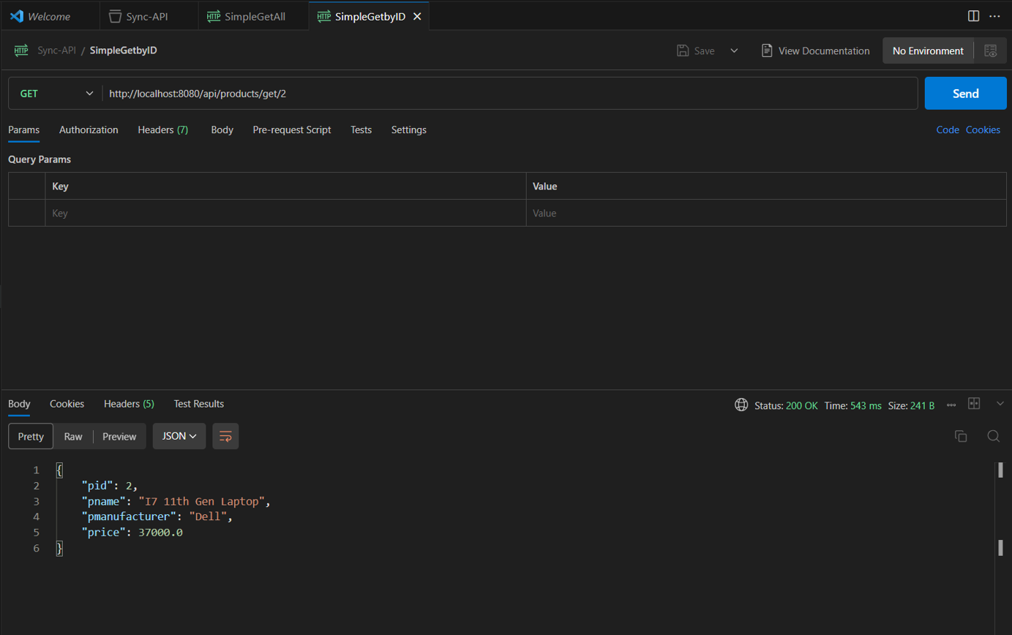

2nd Get call (time reduced from 543ms to 8ms)

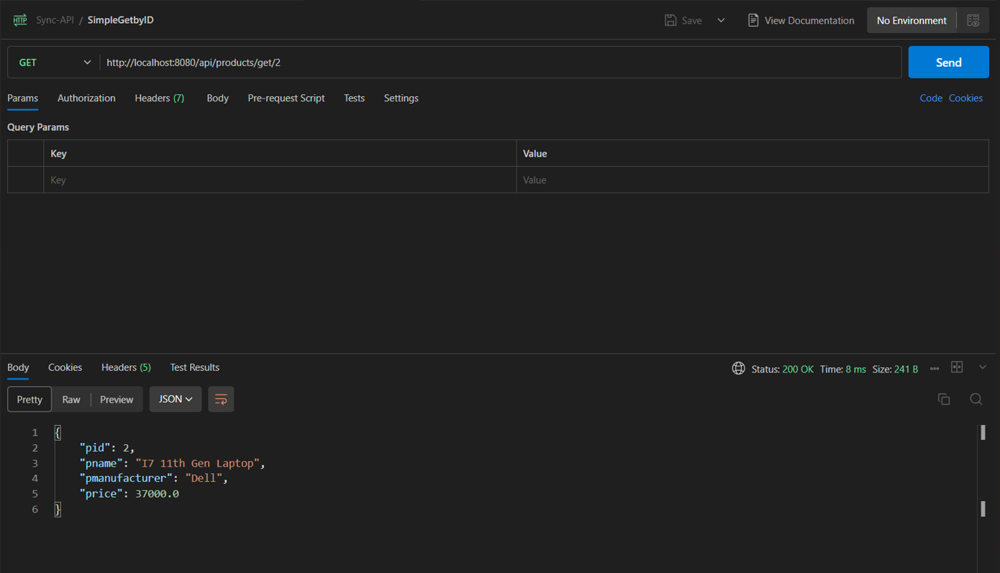

In Redis-cli

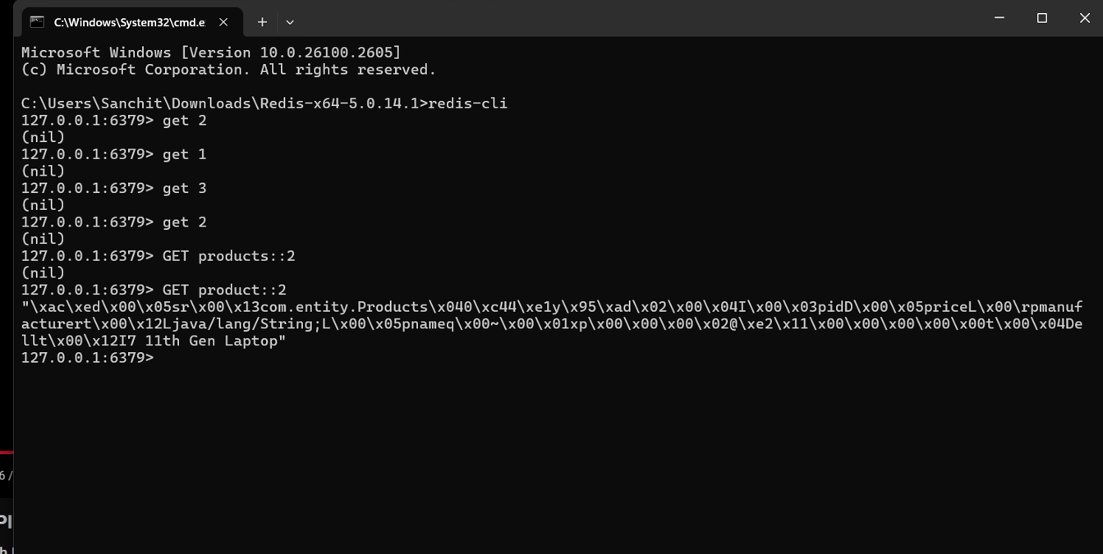

Here when we use serializable on the Redis Key value we can see the actual JSON value.

Code Added:

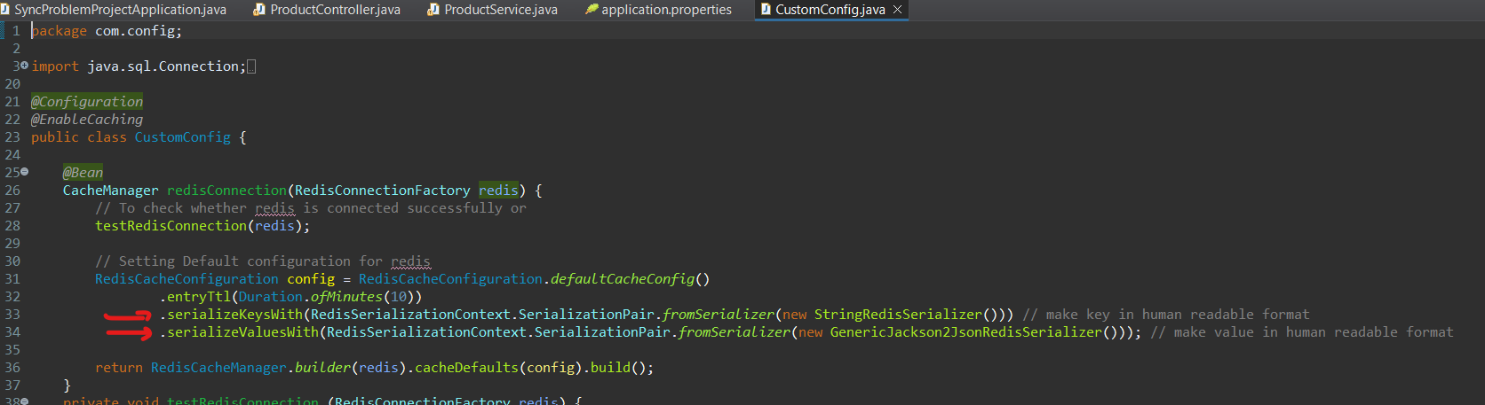

Then result will be like this:

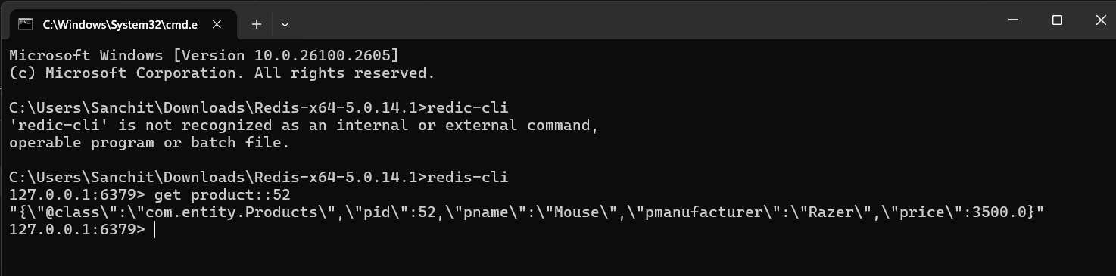

**Parallel Processing**

GET /api/products/parallel

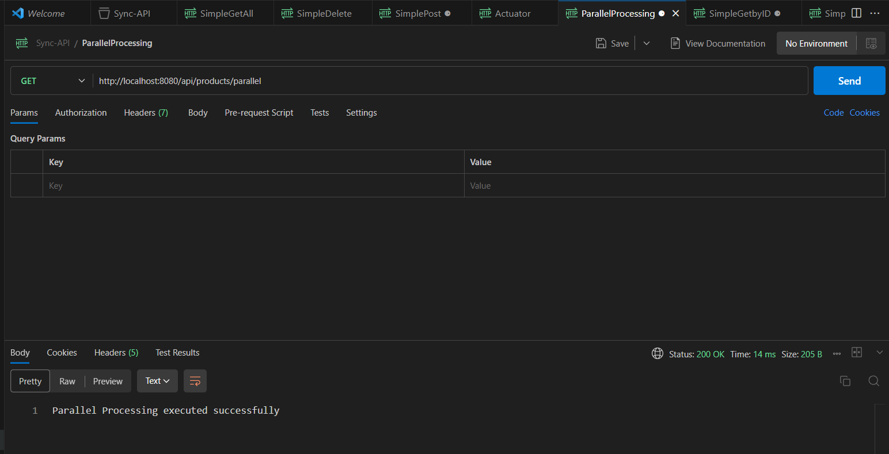

On Console:

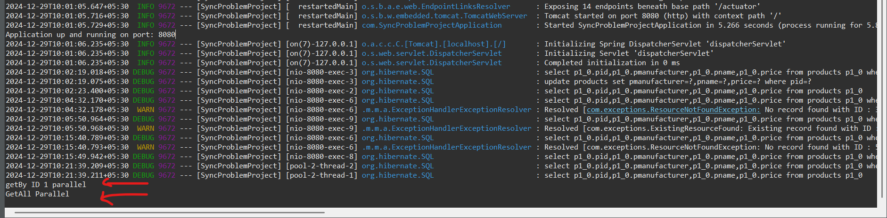

On code end its calling 2 Read methods parallely

